**CV Group 7**

**Plant disease and health status estimation based on leaf image evaluation**

**Reference 1:**

<https://www.sciencedirect.com/science/article/pii/S2214317316300154>

**Detection of plant leaf diseases using image segmentation and soft computing techniques**

In this paper, major emphasis is on Image Segmentation and it is done by using **Genetic Algorithm**

Algorithm begins with a set of solutions called Population

Solutions from one population are chosen and then used to form a new population (typically, a better one)

These solutions are chosen according to their “fitness” - the more appropriate they are, the more probability they have to reproduce.

The basic steps of genetic algorithm are as follows:

(1) [Start] Generate random population of n chromosomes (suitable solutions for the problem).

(2) [Fitness] Evaluate the fitness f(x) of each chromosome x in the population.

(3) [New population] Create a new population by repeating the following steps until the new population is complete.

(a) [Selection] Select two parent chromosomes from a population according to their fitness (the better fitness, the bigger chance to be selected).

(b) [Crossover] With a crossover probability cross over the parents to form a new offspring (children). If no crossover was performed, offspring is an exact copy of parents.

(c) [Mutation] With a mutation probability mutate new offspring at each locus (position in chromosome).

(d) [Accepting] Place new offspring in a new population.

(4) [Replace] Use the newly generated population for a further run of the algorithm.

(5) [Test] If the end condition is satisfied, stop, and return the best solution in the current population.

(6) [Loop] Go to step 2.

Advantages:

* Better than a simple K-Nearest Neighbor algorithm as it that works only if classes are linearly separable.

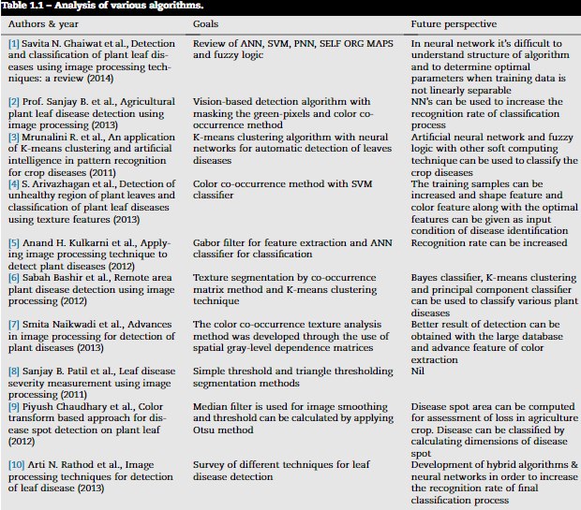

**Reference 2:**

[**https://www.ijareeie.com/upload/january/5_Agricultural%20plant.pdf**](https://www.ijareeie.com/upload/january/5_Agricultural%20plant.pdf)

**Agricultural plant Leaf Disease Detection Using Image Processing**

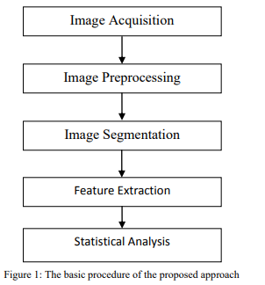

This methodology is simple. It is a vision-based approach where the following steps are followed:

1. RGB image acquisition

2. Convert the input image from RGB to HSV format.

3. Masking the green-pixels

4. Removal of masked green pixels

5. Segment the components

6. Obtain the useful segments

7. Computing the features using color-co-occurrence methodology

8. Evaluation of texture statistics

**Reference 3:**

[**http://www.ipcsit.com/vol20/26-ICAIT2011-A4023.pdf**](http://www.ipcsit.com/vol20/26-ICAIT2011-A4023.pdf)

**An application of K-means clustering and artificial intelligence in pattern recognition for crop diseases**

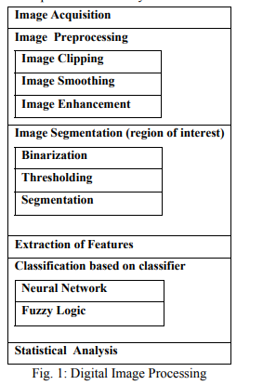

This is similar to the previous paper, but instead of color-co-occurrence methodology, Neural Networks are used and K-Means Clustering is done to classify the diseases.

**Reference 4:**

[**https://www.mdpi.com/2223-7747/9/11/1451/pdf**](https://www.mdpi.com/2223-7747/9/11/1451/pdf)

**Image-Based Plant Disease Identification using Deep Learning**

Three DL meta-architectures including the Single Shot MultiBox Detector (SSD), Faster Region-based Convolutional Neural Network (RCNN), and Region-based Fully Convolutional Networks (RFCN) were applied by using the TensorFlow object detection framework

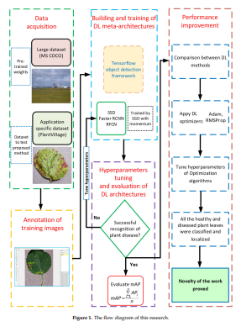

| **Year of Publication** | **Title** | **Methodology Adopted** | **Dataset Used** |
| --- | --- | --- | --- |
| 2007 | [Detection and classification of plant leaf diseases using image processing techniques](https://www.sciencedirect.com/science/article/pii/S2214317316300154) | More emphasis given to **Image Segmentation** using an algorithm names **Genetic Algorithm** |  |
| 2011 | [An application of K-means clustering and artificial intelligence in pattern recognition for crop diseases](http://www.ipcsit.com/vol20/26-ICAIT2011-A4023.pdf) | **K-means clustering** algorithm with neural networks for automatic detection of leaves diseases |  |
| 2013 | [Agricultural plant Leaf Disease Detection Using Image Processing](https://www.ijareeie.com/upload/january/5_Agricultural%20plant.pdf) | Vision-based detection algorithm with **masking** the green-pixels and **color co-occurrence** method |  |
| 2020 | [Image-Based Plant Disease Identification using Deep Learning](https://www.mdpi.com/2223-7747/9/11/1451/pdf) | Using three meta-architectures: Single Shot MultiBox Detector (**SSD**), Faster Region-based Convolutional Neural Network (**RCNN**), and Region-based Fully Convolutional Networks (**RFCN**) |  |
| 2022 | [Plant leaf disease detection using computer vision and machine learning algorithms](https://www.sciencedirect.com/science/article/pii/S2666285X22000218) | RGB conversion to gray, HE, **K-means clustering**, contour tracing to achieve 99% accuracy |  |